The problem that we are having with the original circuit (Figure 0) is that the motor requires 6 volts to run, but the solar battery we are using supplies only 4 volts. Once the motor is running it will continue to run on the 4 volts. So if we could add another battery in series with the original battery, the motor would start by itself.
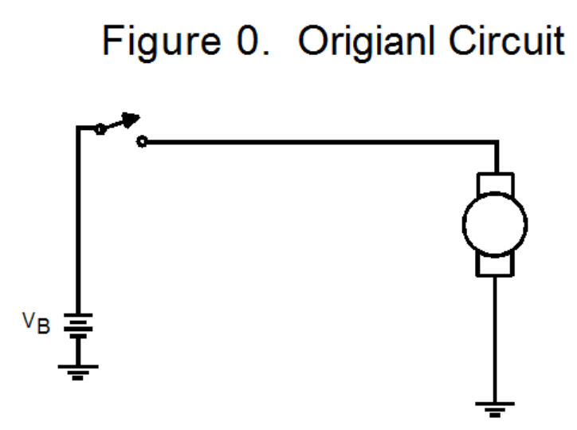
Well a capacitor will act as a temporary battery!
However after the capacitor discharges, it acts as an open circuit. We can add a diode across the capacitor as shown so that when the capacitor discharges, current will flow through the diode to the motor. When the capacitor is charged, no current flows through the diode
As proof of concept, I charge a 1000 ufd capacitor with a diode across it and manually placed it in series with the battery to complete the circuit with the motor.
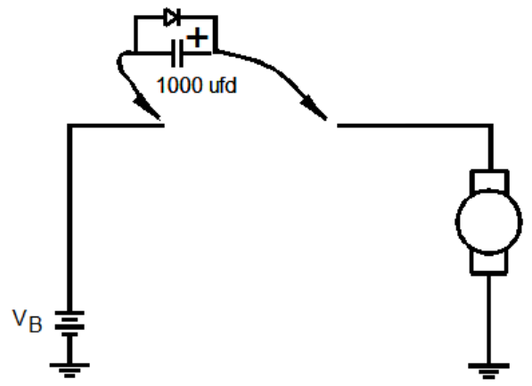
The motor started and ran normally. The first eureka! There is one minor caveat. When the capacitor discharges, the diode forward drop of .7 volts is applying this negative voltage across a polarized capacitor. We will address this later.

If we replaced the SPST (single pole, single throw) push button switch with a DPDT (double pole double throw) push button switch, we could use the circuit below:
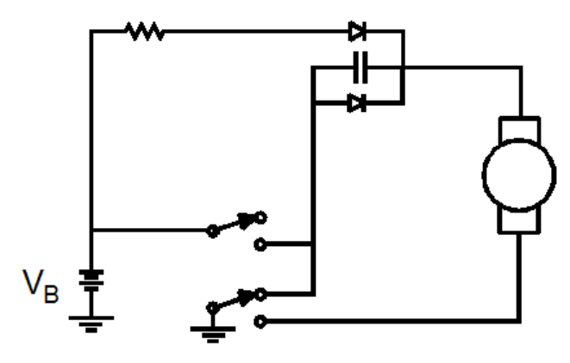
However, if we need to use the original switch, we have to replace the mechanical DPDT switch with an electronic circuit. (I did find a switch so we can build both circuits.)

The first circuit below was not successful.

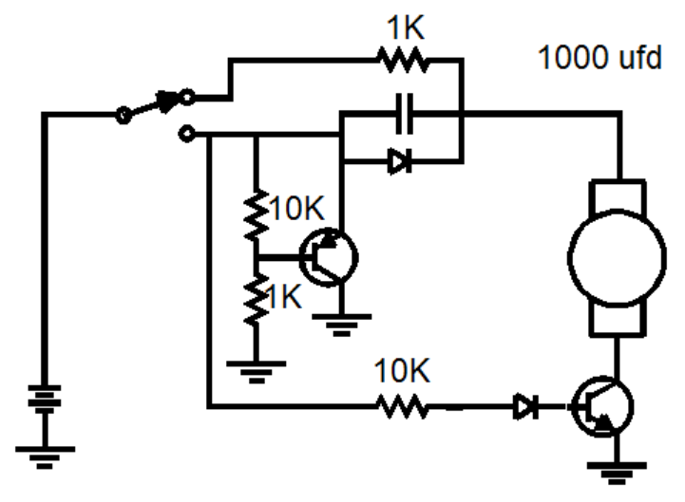

Revised Circuit

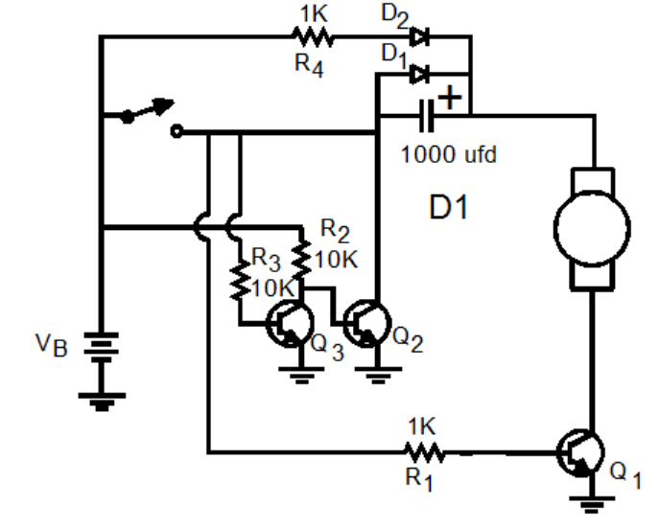 Figure 1
The redesigned circuit violates one of my rules which states: “When you modify designs, do not add parts, take parts out.” However we still need to make the system work.

The first thing to check as proof of concept is that Q₁ will switch on when the switch powers the system.
This is the circuit to test this part of the design

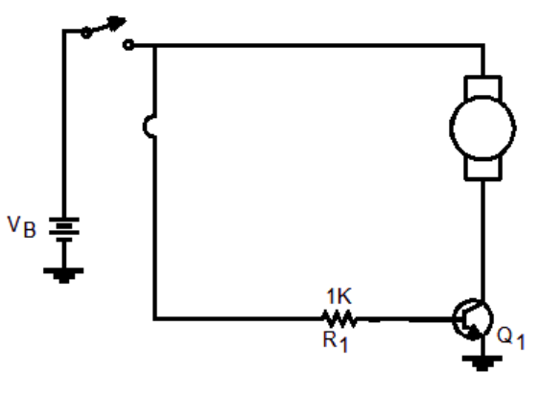
If this works, we will continue the development.

Detailed Description
With the switch off, Figure 2, resistor R2 turns on transistor Q₂ and the capacitor charges through R₄ and D₂. There is a 0.7 volt drop across D₂ and about 0.3 volt drop across Q₂’s collector to emitter junction.
So the capacitor charges to V_{B}-1 volts.

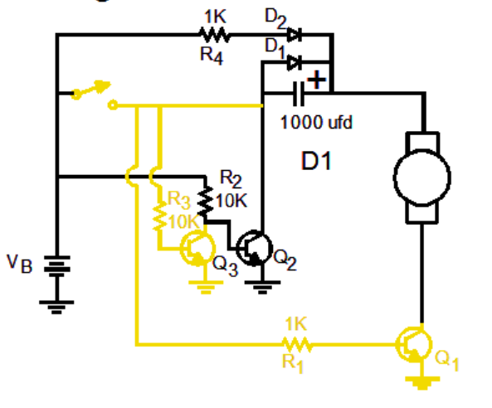

When the switch is on, R₃ turns on transistor Q₃, which turns of Q₂. It also turns on Q1. See Figure 3.
The voltage on the + side of the capacitor is V_{B} +Vc. D₂ prevents current flowing through R₄. So, all of the current flows through the motor. The initial voltage across the motor is V_{B} + V_{B} -1 volt. This is enough to start the motor.
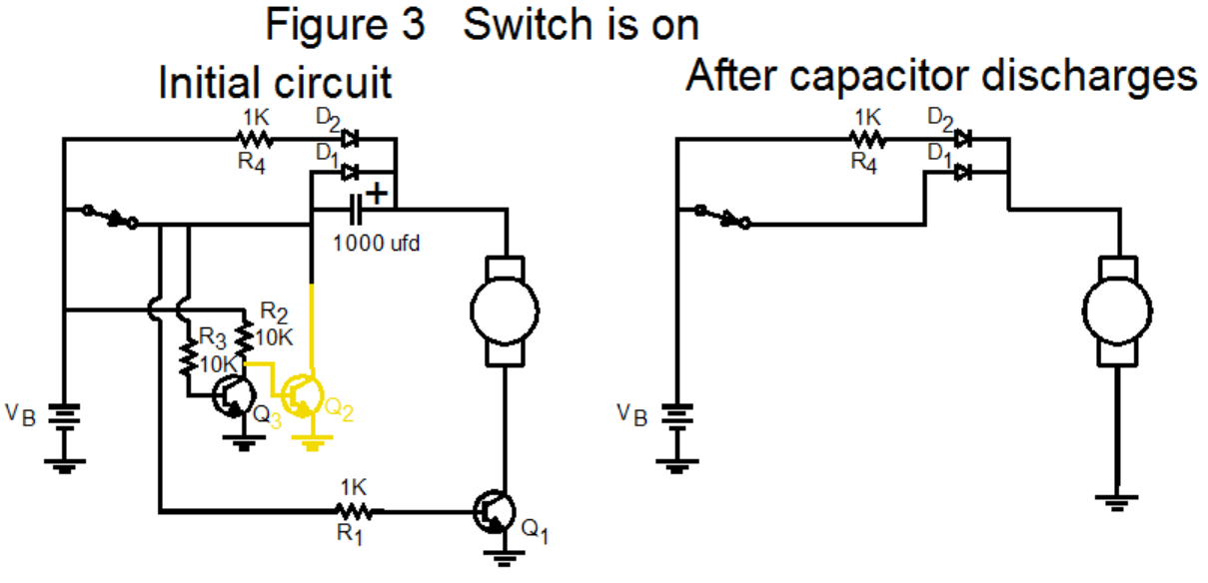
After the capacitor discharges, the voltage across the motor is V_{B}-0.6 volts
When the switch is released the capacitor will charge up again. It will take about 4 times R₄*C or :
4* 1000*.001 or 4 seconds to completely recharge.

Although Figure 1 describes exactly how the circuit works, ego and my devotion to Scott Adam’s Dilbert comic strip would make me redraw the circuit to confuse anyone, especially my pointy haired boss,



from casually trying to understand how it works. Notice that diodes D₁ and D₂ form the same configuration as a PNP transistor!

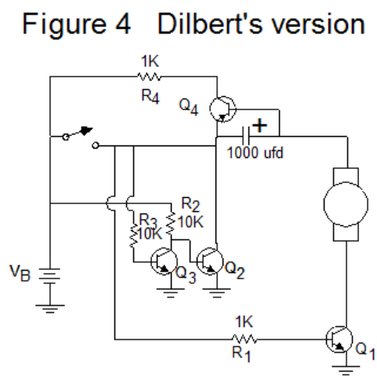

Switch Circuit When the switch is off, ie. not pressed this is the equivalent circuit
Figure S1 Figure S2 Figure S3

The capacitor C, charges through resistor R to the battery voltage less the forward drop across D2. D1 does not conduct and can be considered not in the circuit in this mode.

When the switch is pressed, the battery is connected directly to the capacitor and the motor is connected to the battery’s negative terminal.

The instant the switch is pressed the equivalent circuit is shown below.

The initial voltage applied to the motor is V_{B} +V_{B}-V_{D2} or almost 2V_{B}. If the battery voltage was 4 volts, the initial voltage across the motor would be 7.3 volts

As the capacitor discharges, the voltage across the motor drops. When the capacitor is discharged the motor would stop since the capacitor becomes an open circuit. However, diode D1 begins to conduct and provides current to keep the motor running. No current flows through the resistor and the diode D2 except for a short period of time when the switch is released and the capacitor is charging up (see Figure S3). The actual time is about 4*RC. If R= 1,000 ohms and C= 1,000 ufds, current flows for about 4 seconds.

The “steady state” circuit configuration after the switch is pressed and held is shown below.
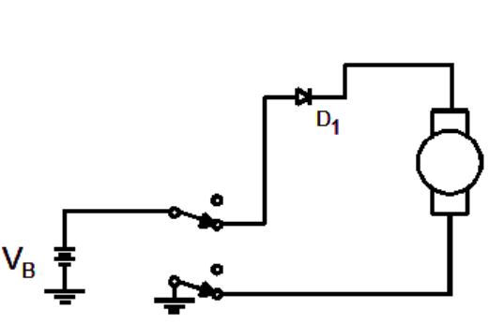

We fabricated the circuit above on a vector board and soldered the parts because the switch would not span the middle of the proto-boaard.
We used a 1K resistor and a 1,000 uFD capacitor as described above.

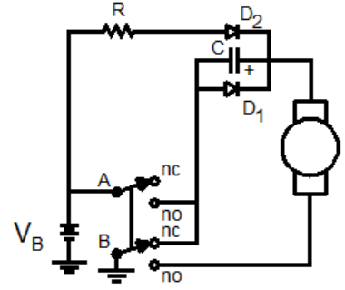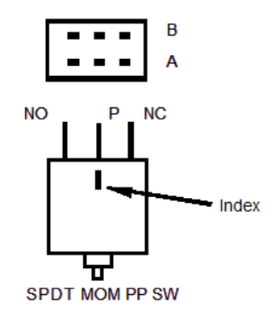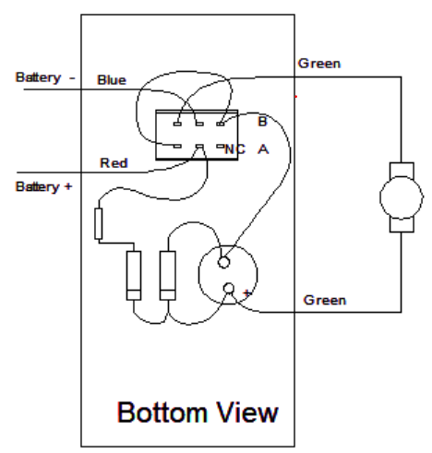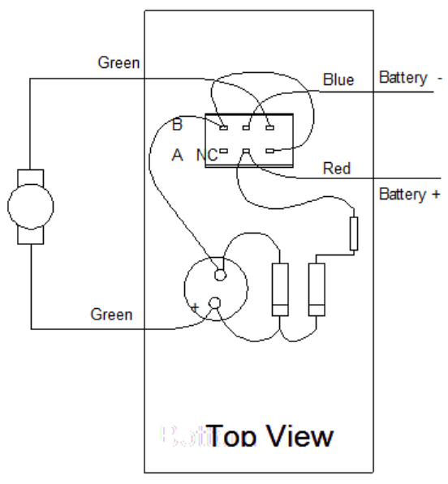

The circuit would not start the motor!

I disconnected the motor and measured the voltage across the green wires and found it was greater than 7 volts. This means the circuit is working as designed. It is doubling the voltage to the motor. The motor will not start because there is not enough energy stored in the capacitor to drive the motor.

We will increase the value of the capacitor (by adding another 1,000 ufd capacitor in parallel) and try it again. We may reduce the value of the resistor to 100 ohms to reduce the charging time to 0.8 seconds.

